# Español

<https://www.nytimes.com/es/2019/04/24/maratonistas-kenia/?action=click&rref=collection%2Fsectioncollection%2Fnyt-es&contentCollection=inicio&region=rank&module=package&version=masinformacion&contentPlacement=5&pgtype=Homepage>

En Kenia los corredores de élite no tienen el futuro asegurado

**Por**[**JONATHAN W. ROSEN**](https://www.nytimes.com/es/people/jonathan-w-rosen/)**24 de abril de 2019**

[Volver al artículo principal](https://www.nytimes.com/es/2019/04/24/maratonistas-kenia/?action=click&rref=collection%2Fsectioncollection%2Fnyt-es&contentCollection=inicio&region=rank&module=package&version=masinformacion&contentPlacement=5&pgtype=Homepage#story-continues-1)Comparte esta página

* [Share](javascript:;)
* [Tweet](javascript:;)
* [Email](javascript:;)

[Continue reading the main story](https://www.nytimes.com/es/2019/04/24/maratonistas-kenia/?action=click&rref=collection%2Fsectioncollection%2Fnyt-es&contentCollection=inicio&region=rank&module=package&version=masinformacion&contentPlacement=5&pgtype=Homepage#story-continues-2)Foto

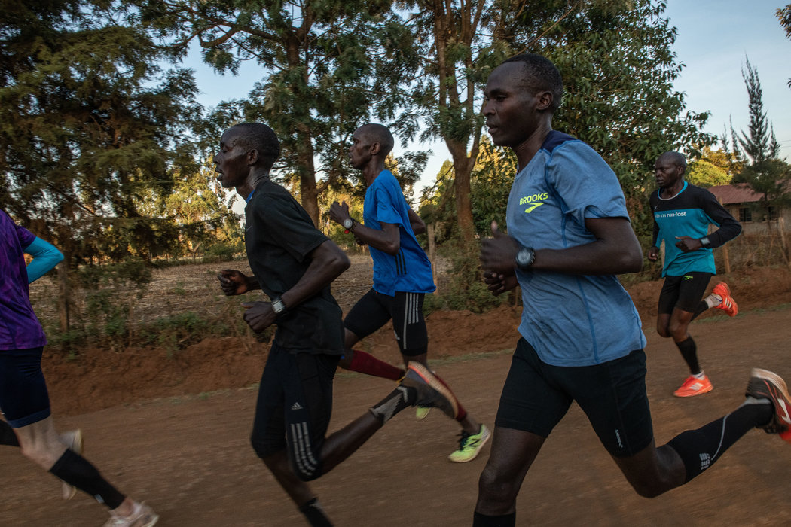

Corredores matutinos entrenan en Eldoret, Kenia. Shadrack Biwott (segundo de derecha a izquierda) regresó al país para entrenar antes del Maratón de Boston del 15 de abril de 2019.CreditAndrew Renneisen para The New York Times

[Read in English](https://www.nytimes.com/2019/04/22/sports/kenyan-runners.html?ref=nyt-es&mcid=nyt-es&subid=article)

*[Si quieres recibir las noticias y reportajes de The New York Times en Español en tu correo, suscríbete*[*aquí*](https://www.nytimes.com/newsletters/el-times)*a El Times]*

ELDORET, Kenia — Hace diez años en la ciudad portuaria de Róterdam, Duncan Kibet estaba tendido sobre el pavimento mientras intentaba procesar el récord que acababa de imponer y cómo esa marca estaba a punto de cambiarle la vida.

Esa mañana del 5 de abril de 2009, cuando puso la punta de sus pies sobre la línea de salida en la vigesimonovena edición del Maratón de Róterdam, llevaba casi una década ganándose la vida como atleta de élite. Pero su mejor marca personal —de dos horas, siete minutos y 53 segundos— no hacía de él alguien muy conocido en Kenia, el hogar de la mayor concentración de talento de corredores de larga distancia en el mundo. Hasta que ese día corrió 2:04:27 en Holanda, con lo cual se convirtió en el poseedor del récord nacional de Kenia y el segundo maratonista más rápido de la historia.

[**EXPLORA NYTIMES.COM/ES**](https://www.nytimes.com/es/)

[](https://www.nytimes.com/es/2018/04/17/la-paz-bolivia-52-lugares/?mcid=recirc&subid=cur)

[La sorpresa de las mujeres de La Paz](https://www.nytimes.com/es/2018/04/17/la-paz-bolivia-52-lugares/?mcid=recirc&subid=cur)

Con la victoria, Kibet —quien creció en la pobreza, como muchos de sus colegas corredores— obtuvo también una cantidad sustancial de dinero. Ganó 180.000 dólares, incluidos sus honorarios de aparición, y poco después firmó un contrato con Nike por 100.000 dólares. En Kenia, donde el costo de la vida es bajo, un pago como ese tendría que haberle durado toda una vida. Sin embargo, es rara la ocasión en que eso sucede, y Kibet no fue la excepción.

Le compró una casa a su madre en Eldoret, la capital de facto de los corredores en Kenia, y le regaló una camioneta Toyota. Pagó las colegiaturas de varios parientes e hizo una donación a un hogar de huérfanos. Compró trajes de sastres italianos, así como gorras y camisetas de béisbol que mandó traer desde Estados Unidos.

Una lesión en la ingle le impidió terminar los maratones de Berlín y Londres. Su rendimiento físico menguó y, dos años después de su triunfo en Róterdam, prácticamente se quedó en bancarrota y sin trabajo.

“Terminé gastando todo”, comentó Kibet, de 40 años, una tarde reciente desde su hogar en Eldoret, un apartamento de una habitación en un edificio de concreto que se encuentra entre dos gasolineras.

[Continue reading the main story](https://www.nytimes.com/es/2019/04/24/maratonistas-kenia/?action=click&rref=collection%2Fsectioncollection%2Fnyt-es&contentCollection=inicio&region=rank&module=package&version=masinformacion&contentPlacement=5&pgtype=Homepage#story-continues-10)Foto

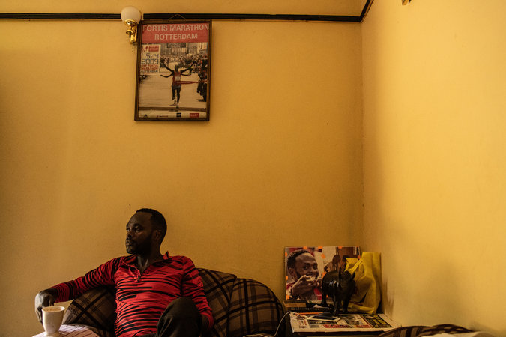

Duncan Kibet, de 40 años, pasó de tener récords maratonistas a tener problemas financieros.CreditAndrew Renneisen para The New York Times

Aquí en el valle Rift, la región elevada que alberga a la gran mayoría de los atletas de élite en Kenia, muchos aún ven en las carreras profesionales un escape de la pobreza. Pero solo pocos de los miles de jóvenes atletas que se abalanzan a los campos de entrenamiento cada año logran ganarse la vida corriendo. La estabilidad económica a largo plazo es menos frecuente de lo que muchos creen, incluso para los que ascienden a la cumbre del deporte —como Kibet— y ganan uno de los principales maratones. Estos incluyen el de Boston, donde el keniano Lawrence Cherono obtuvo el primer lugar y 150.000 dólares el pasado 15 de abril, o el de Londres, programado para el 28 de abril.

Benjamin Limo, campeón mundial de 2005 en la carrera de 5000 metros y exrepresentante de Kenia en la Asociación Internacional de Federaciones de Atletismo, calculó que tan solo el 25 por ciento de los exatletas de más alto nivel del país africano viven de manera sostenible. “Más de la mitad de verdad están en problemas”, comentó.

Los campeones kenianos a menudo tienen grandes redes familiares que mantener. La mayoría no ha terminado el bachillerato, algunos apenas están alfabetizados y muy pocos tienen experiencia para administrar el dinero. Según atletas veteranos, una infusión repentina de dinero en efectivo puede distraer del entrenamiento y resultar en un gasto descuidado. “Cuando tomas mucho alcohol, te vuelves estúpido: no sabes qué estás haciendo”, señaló Moses Tanui, uno de los pioneros kenianos en carreras que ganó el Maratón de Boston dos veces en los años 90. “Sucede lo mismo cuando tienes mucho dinero”.

[Continue reading the main story](https://www.nytimes.com/es/2019/04/24/maratonistas-kenia/?action=click&rref=collection%2Fsectioncollection%2Fnyt-es&contentCollection=inicio&region=rank&module=package&version=masinformacion&contentPlacement=5&pgtype=Homepage#story-continues-14)Foto

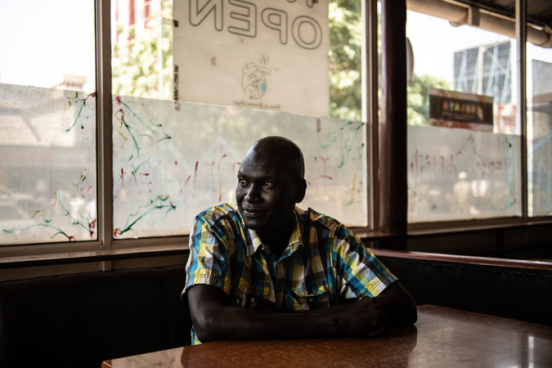

Conocidos de Robert Kipkoech Cheruiyot, quien ganó el Maratón de Boston en cuatro ocasiones, comentan que suele pedirles dinero. CreditAndrew Renneisen para The New York Times

En Eldoret hay una buena cantidad de estafadores, y los atletas con dinero en abundancia son blancos fáciles. Una estafa común involucra la venta de títulos falsos de propiedades. En 2011, debido a un apuro financiero, Kibet vendió la casa que había comprado después de ganar en Róterdam. Según Kibet, el comprador le pagó solo la mitad del valor a cambio de pagarle lo demás con el título de una propiedad más pequeña. El acuerdo resultó ser un fraude.

Los problemas también pueden tener su origen en las relaciones íntimas, en particular para las mujeres. Muchas personas en Eldoret aseguran que las atletas tienden a manejar las victorias de una manera más responsable. No obstante, en una cultura en la que los hombres suelen encargarse de las finanzas familiares, las maratonistas también son más vulnerables a la explotación. Las atletas hablan de hombres “hienas” que se presentan a competencias juveniles y cazan estrellas femeniles nacientes, muchas de las cuales aún están cursando el bachillerato. Un reportaje publicado en febrero por el periódico keniano The Star identificó al menos a dieciséis atletas mujeres que habían perdido decenas de miles de dólares en activos por culpa de hombres.

[Continue reading the main story](https://www.nytimes.com/es/2019/04/24/maratonistas-kenia/?action=click&rref=collection%2Fsectioncollection%2Fnyt-es&contentCollection=inicio&region=rank&module=package&version=masinformacion&contentPlacement=5&pgtype=Homepage#story-continues-17)Foto



Los caminos terrosos de Eldoret son un sitio importante de entrenamiento para los corredores de élite.CreditAndrew Renneisen para The New York Times

En contraste con muchos excampeones que han padecido dificultades, Kibet habla abiertamente sobre sus problemas económicos. Creció con poco y lo expulsaron de la escuela por mala conducta. Hizo trabajos como moler maíz en una fábrica de harina usada para el platillo ugali y fue “matatu”, que es el apodo que reciben los cobradores de microbús.

Empezó a correr inspirado en su hermano mayor, Luke Metto, un maratonista que competía en Francia y tenía una marca de 2:10:57. Metto le compró su primer par de zapatos para correr, puso a Kibet en contacto con un representante y le pagó su primer vuelo para competir en el extranjero, a los 22 años.

Pero cuando ganó en Róterdam “empezó a vivir como si no hubiera mañana”, comentó Shadrack Biwott, hermano menor de Kibet quien vive en California y también compite como maratonista. “Duncan quería ayudar a toda la gente que pudiera y varios se aprovecharon de eso”.

[Continue reading the main story](https://www.nytimes.com/es/2019/04/24/maratonistas-kenia/?action=click&rref=collection%2Fsectioncollection%2Fnyt-es&contentCollection=inicio&region=rank&module=package&version=masinformacion&contentPlacement=5&pgtype=Homepage#story-continues-21)Foto



Un calentamiento antes de una sesión de práctica en Eldoret CreditAndrew Renneisen para The New York Times

El Ministerio de Tierras de Kenia está en proceso de digitalizar las bases de datos de los títulos de propiedades para evitar los fraudes. Una nueva generación está aprendiendo de los errores de la anterior en temas financieros, aunque los corredores no reciben mucha orientación. Renato Canova, un entrenador italiano que ha trabajado durante dos décadas con corredores kenianos, señaló que la mayoría de los representantes, a cargo de arreglar las apariciones en carreras y los patrocinios, están radicados en en Estados Unidos o Europa y no ayudan a gestionar asuntos económicos.

Los atletas denuncian que Athletics Kenya, la federación nacional que supervisa el deporte en nombre del gobierno keniano, tampoco ayuda. El órgano ha estado involucrado en una serie de escándalos, entre ellos uno en el que funcionarios anteriores malversaron pagos hechos por Nike. Limo, el excampeón y antes representante de Athletics Kenya, propuso durante su gestión que se creara un plan de jubilación para los atletas, pero no logró obtener el respaldo suficiente.

Por el momento, Kibet se mantiene a flote con las comisiones de ventas de títulos de propiedades legítimos, mientras su abogado intenta recuperar las tierras que vendió al comprador fraudulento en 2011. Kibet comentó que quiere terminar los estudios que quedaron truncos y quizá ser investigador criminalista (dijo que es fanático de la serie de televisión *CSI*). Y aún sueña con correr.

“Con solo tres meses de mucho entrenamiento”, afirmó, “estaré listo”.

# Ingles

<https://www.nytimes.com/2019/04/22/sports/kenyan-runners.html?ref=nyt-es&mcid=nyt-es&subid=article>

For Kenyan Runners, Winning Can Be a Road to Ruin

Success in a major long-distance race can lift a Kenyan runner out of poverty overnight. It can also bring plenty of pitfalls, as fame and wealth often do.

Scores of runners chase riches every day in Kenya's highlands. Shadrack Biwott, second from right, returned from his base in California to train ahead of the recent Boston Marathon. His brother Duncan Kibet is a former marathon record holder who has struggled to stay financially afloat.CreditAndrew Renneisen for The New York Times

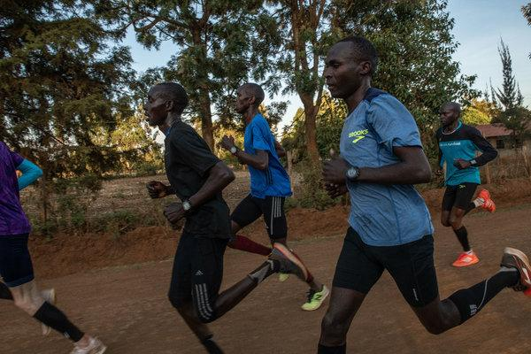

Image

Scores of runners chase riches every day in Kenya's highlands. Shadrack Biwott, second from right, returned from his base in California to train ahead of the recent Boston Marathon. His brother Duncan Kibet is a former marathon record holder who has struggled to stay financially afloat.CreditCreditAndrew Renneisen for The New York Times

**By Jonathan W. Rosen**

* April 22, 2019
  + *18*

ELDORET, Kenya— Ten years ago, in the Dutch port city of Rotterdam, Duncan Kibet lay spread-eagle on the pavement, attempting to process the record-setting run he had just completed and how it was about to change his life.

When he toed the starting line of the 29th Rotterdam Marathon that morning, April 5, 2009, he had been earning a living as an elite athlete for nearly a decade. But with a marathon personal best of only 2 hours 7 minutes 53 seconds, he was hardly a household name in Kenya, home to the world’s greatest concentration of distance running talent. Then he ran a 2:04:27, nearly three and a half minutes faster, making him Kenya’s national record holder and the second fastest marathoner in history.

The win was worth big money for Kibet, who, like most of his running peers, had grown up poor. He earned $180,000, including his appearance fee. Nike would soon sign him to a contract worth $100,000. In Kenya, where the cost of living is low, a payday like that was supposed to set him up for life. But it rarely works out that way, and it didn’t for Kibet.

He bought a house for his mother in Eldoret, the de facto Kenyan running capital, and a Toyota Hilux truck. There were school fees for various relatives and contributions to a home for orphans. He bought Italian suits and had baseball caps and shirts shipped from the United States.

ADVERTISEMENT

A groin injury kept him from finishing marathons in Berlin and London. His fitness waned, and two years after his Rotterdam triumph, he was essentially broke and out of work.

Kibet, 40, had morning tea in his apartment. Two years after a big payday at the 2009 Rotterdam Marathon, he was essentially broke and out of work.CreditAndrew Renneisen for The New York Times

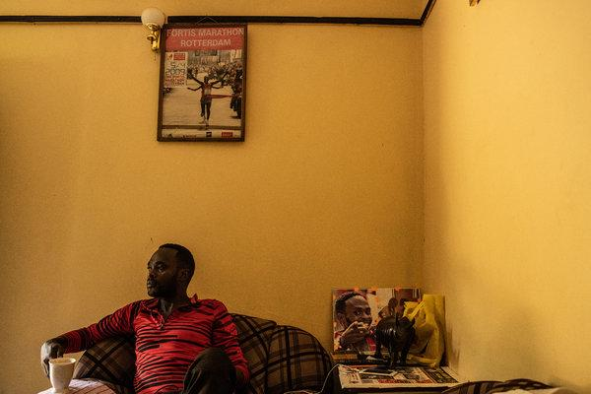

Image

Kibet, 40, had morning tea in his apartment. Two years after a big payday at the 2009 Rotterdam Marathon, he was essentially broke and out of work.CreditAndrew Renneisen for The New York Times

“I ended up spending everything,” Kibet, 40, said on a recent afternoon from his home in Eldoret, a one-bedroom apartment in a concrete-block building that sits between two gas stations.

Here in the Rift Valley, the high-altitude region that is home to the vast majority of Kenya’s elite athletes, the belief in running as an escape from poverty remains prevalent, but few among the thousands of young athletes who flock to training camps each year ever make a living from running. Even for those like Kibet who ascend to the sport’s pinnacle, long-term financial stability is rarer than most realize, even if they win one of the world’s biggest marathons, such as Boston, where Kenya’s Lawrence Cherono last week took first place and $150,000, or London on April 28.

Benjamin Limo, the 2005 world champion in the 5,000 meters and a former Kenyan representative to the International Association of Athletics Federations, the sport’s governing body, estimated that only 25 percent of the country’s former top-level athletes were living in a “sustainable” manner. “More than half are really struggling,” he said.

**Editors’ Picks**

[[](https://www.nytimes.com/2019/04/23/magazine/kay-jewelry-sexual-harassment.html?fallback=0&recId=1KMPIKgYJeQHnkRfCab5Hk2EWhI&locked=0&geoContinent=SA&geoRegion=C&recAlloc=story&geoCountry=AR&blockId=home-featured&imp_id=957122059)](https://www.nytimes.com/2019/04/23/magazine/kay-jewelry-sexual-harassment.html?fallback=0&recId=1KMPIKgYJeQHnkRfCab5Hk2EWhI&locked=0&geoContinent=SA&geoRegion=C&recAlloc=story&geoCountry=AR&blockId=home-featured&imp_id=957122059)

[The Company That Sells Love to America Had a Dark Secret](https://www.nytimes.com/2019/04/23/magazine/kay-jewelry-sexual-harassment.html?fallback=0&recId=1KMPIKgYJeQHnkRfCab5Hk2EWhI&locked=0&geoContinent=SA&geoRegion=C&recAlloc=story&geoCountry=AR&blockId=home-featured&imp_id=957122059)

[[](https://www.nytimes.com/2019/04/23/well/live/how-gay-are-you.html?fallback=0&recId=1KMPIKgYJeQHnkRfCab5Hk2EWhI&locked=0&geoContinent=SA&geoRegion=C&recAlloc=story&geoCountry=AR&blockId=home-featured&imp_id=358570631)](https://www.nytimes.com/2019/04/23/well/live/how-gay-are-you.html?fallback=0&recId=1KMPIKgYJeQHnkRfCab5Hk2EWhI&locked=0&geoContinent=SA&geoRegion=C&recAlloc=story&geoCountry=AR&blockId=home-featured&imp_id=358570631)

[How Gay Are You?](https://www.nytimes.com/2019/04/23/well/live/how-gay-are-you.html?fallback=0&recId=1KMPIKgYJeQHnkRfCab5Hk2EWhI&locked=0&geoContinent=SA&geoRegion=C&recAlloc=story&geoCountry=AR&blockId=home-featured&imp_id=358570631)

[[](https://www.nytimes.com/2019/04/19/style/modern-love-no-more-hiding-my-son-or-my-love.html?fallback=0&recId=1KMPIKgYJeQHnkRfCab5Hk2EWhI&locked=0&geoContinent=SA&geoRegion=C&recAlloc=story&geoCountry=AR&blockId=home-featured&imp_id=521403213)](https://www.nytimes.com/2019/04/19/style/modern-love-no-more-hiding-my-son-or-my-love.html?fallback=0&recId=1KMPIKgYJeQHnkRfCab5Hk2EWhI&locked=0&geoContinent=SA&geoRegion=C&recAlloc=story&geoCountry=AR&blockId=home-featured&imp_id=521403213)

[With the Birth of My Son, I Stopped Hiding](https://www.nytimes.com/2019/04/19/style/modern-love-no-more-hiding-my-son-or-my-love.html?fallback=0&recId=1KMPIKgYJeQHnkRfCab5Hk2EWhI&locked=0&geoContinent=SA&geoRegion=C&recAlloc=story&geoCountry=AR&blockId=home-featured&imp_id=521403213)

ADVERTISEMENT

Kenyan champions often have large networks of family to support. Most haven’t finished high school, some are barely literate and few have any experience managing money. A sudden infusion of cash, veteran athletes said, can distract from training and lead to careless spending. Some call it intoxicating. “When you drink a lot of alcohol you become stupid — you don’t know what you’re doing,” said Moses Tanui, a Kenyan marathoning pioneer who won the Boston Marathon twice in the 1990s. “It’s the same when you get a lot of money.”

Robert Kiprono Cheruiyot, who was little known when he set the Frankfurt Marathon course record in 2008 and ran a course record in Boston two years later, avoided the pitfalls thanks to a trusty lawyer who guided him through a series of investments, including a 20-acre tea estate that has given him a comfortable income since his running days ended.

Many are not as fortunate. Eldoret, like most cities in Kenya, is home to its share of con artists, and athletes flush with cash are easy targets. A common scam involves the sale of fake land titles. In 2011, Kibet sold the house he had purchased after Rotterdam in a financial pinch. The buyer, he claimed, paid him only half the value, but gave him the title to another, smaller property. That deal turned out to be a fraud.

**Marc Stein's Newsletter**

Marc Stein has covered Jordan. He's covered Kobe. And LeBron vs. the Warriors. Go behind the N.B.A.'s curtain with the league's foremost expert.

SIGN UP

Runners stretched before morning training outside Eldoret, Kenya.CreditAndrew Renneisen for The New York Times

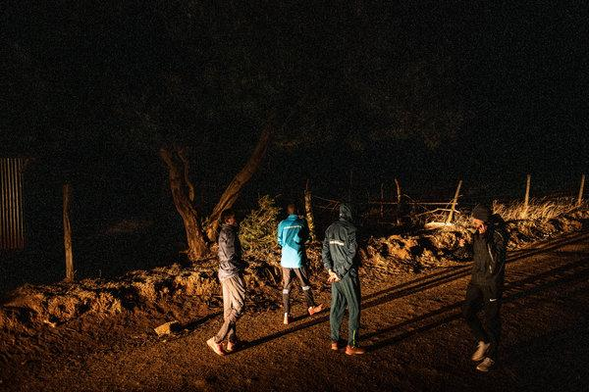

Image



Runners stretched before morning training outside Eldoret, Kenya.CreditAndrew Renneisen for The New York Times

Trouble can also stem from intimate relationships, particularly for women. Many in Eldoret say female athletes tend to manage winnings more responsibly. Yet in a culture in which men generally take charge of family finances, they are also more vulnerable to exploitation. Athletes speak of male “hyenas” who show up to junior-level competitions and scout for emerging female stars, many of them still in high school. Reporting in February by The Star, a Kenyan newspaper, identified at least 16 female athletes who had lost tens of thousands of dollars worth of assets to men.

Those who have fallen hardest include some of Kenya’s biggest stars. Robert Kipkoech Cheruiyot, a four-time Boston Marathon winner (who is not related to Robert Kiprono Cheruiyot), won $500,000 as the inaugural World Marathon Majors series champion. In multiple interviews, he insisted that he was living well and enjoying his treasured Dunhill cigarettes, but several former training partners said he had sold most of the properties he purchased and routinely asked to borrow money.

Samuel Wanjiru won the 2008 Olympic marathon, then began drinking heavily. He died after an apparent fall from a balcony in 2011. The death was initially ruled a suicide, but a government pathologist later determined he had been struck with an object in the back of the head.

ADVERTISEMENT

In contrast to many former champions who have struggled, Kibet speaks openly about his financial challenges. Like many of his peers, he grew up with little: His father, a truck driver, was not around much, and the family relied on money from traditional spirits that their mother brewed out of their home. Kicked out of school in 11th grade for misbehaving, he worked a series of odd jobs: at a factory grinding maize to make the staple dish ugali and as a conductor on a minibus, or matatu, in charge of collecting fares.

Robert Kipkoech Cheruiyot, a four-time winner of the Boston Marathon, says he still lives well. Others say he often asks for money.CreditAndrew Renneisen for The New York Times

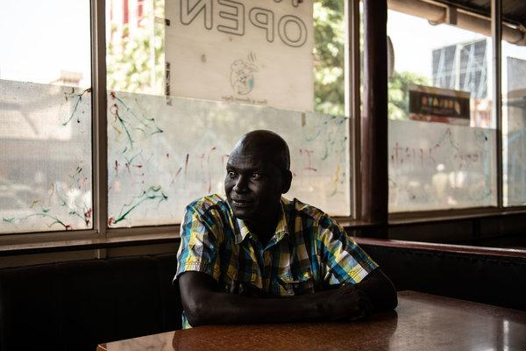

Image



Robert Kipkoech Cheruiyot, a four-time winner of the Boston Marathon, says he still lives well. Others say he often asks for money.CreditAndrew Renneisen for The New York Times

He eventually got into running through his older brother, Luke Metto, a 2:10:57 marathoner who was competing in France. Metto bought him his first pair of running shoes, helped connect him to a manager and paid for his first flight to compete abroad at age 22. He scratched out a living running internationally for eight years before Rotterdam.

“That race changed everything,” he said.

The win enabled purchases like the new home for his mother. But the money and the accompanying fame led to temptations. Nicknamed Jamaica in school because of his westernized manner of speech and dress, he sported a hipster beard and a flashy necklace, and carried an iPhone when it was still a novelty. He hung out in pool halls, where he ran the table with customized cue sticks and sipped on Amarula, a South African cream liqueur.

“He was living life as if there’s no tomorrow,” said Shadrack Biwott, Kibet’s younger brother and an elite runner now based in California. Biwott finished third at the 2018 Boston Marathon and 15th last Monday. “Duncan wanted to help people as much as he could, and some of his friends took advantage of that.”

There is some hope for change. Kenya’s Ministry of Lands is in the process of digitizing land title databases to prevent fraud. A new generation is learning from the mistakes of the old one, though Renato Canova, an Italian coach who has worked with Kenyan runners for two decades, said most managers, who arrange race appearances and endorsements, were based in the United States or Europe and offered little guidance on financial matters.

ADVERTISEMENT

Athletes say the same about Athletics Kenya, the national federation that oversees the sport on behalf of the Kenyan government. It has gotten mixed up in a series of scandals, including the embezzlement of payments from Nike by former top officials. As an Athletics Kenya representative, Limo proposed the creation of a pension plan to assist athletes struggling in retirement. He failed to gain support. Athletics Kenya officials, including its president, Jackson Tuwei, did not respond to repeated requests for comment.

A training run on the dirt roads outside Eldoret, a training hub for elite runners.CreditAndrew Renneisen for The New York Times



Image



A training run on the dirt roads outside Eldoret, a training hub for elite runners.CreditAndrew Renneisen for The New York Times

Now Kibet, like many former stars, is entering middle age unsure of what to do next. These days he spends much of his time in his apartment, where he lives alone, watching crime dramas or CNN. Occasionally, he said, he uses his connections to help friends selling land find reputable buyers; the small commissions help him stay afloat. He visits with his 8-year-old daughter, Alexis, who lives with her mother, and his lawyer, who is trying to reclaim the property he sold in 2011, arguing the fraudulent deal should nullify the whole transaction. The home’s value has since risen to $230,000 from $90,000 — Kenya’s property markets are booming.

Over cups of tea in his apartment, below a framed photo of his Rotterdam finish with arms raised in triumph, he said he had been thinking about becoming a criminal investigator. After all, he said, he was a victim of land fraud and is addicted to crime dramas, such as the “C.S.I.” shows. He would need to finish high school first — in his 40s — then pursue higher education.

Running still has its lure as well. He hasn’t completed a race since 2014, when he ran a disappointing 2:18:38 marathon in a comeback attempt in China. Despite a nagging groin injury, he dreams of standing on a starting line next to his brother.

“Give me three good months of training,” he said. “I’ll be ready.”